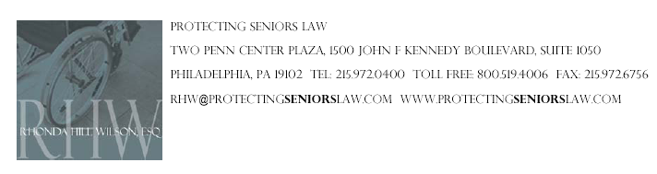

FOR IMMEDIATE RELEASE:
Contact: Leah Rice
leah@furiarubel.com / 215-340-0480

Philadelphia Attorney Hill Wilson Appointed to Salvation Army of Greater Philadelphia Advisory Board

PHILADELPHIA (April 30, 2008) – The Salvation Army of Greater Philadelphia has appointed Rhonda Hill Wilson, Esquire, to its advisory board. Hill Wilson’s past leadership and dedication to serving the charitable organization prompted the appointments.

“I believe it is my duty as an attorney and a Christian to give back to my community and assist those less fortunate than I,” said Hill Wilson. “I am a proud supporter of The Salvation Army’s message of hope and healing and am honored to serve on its advisory board.”

As a member of the advisory board, Hill Wilson will help ensure that The Salvation Army continues to deliver outstanding services to those in need. Last year the organization provided nearly 617,000 meals and more than 322,000 nights of lodging to Philadelphia-area residents who otherwise would have gone hungry or slept in the streets.

“For 128 years, the ongoing commitment and support of our executives and our advisory board members has enabled those living in the Philadelphia region to turn to The Salvation Army in their greatest times of need,” stated Kyra McGrath, advisory board chair for The Salvation Army of Greater Philadelphia. “We would not be able to ‘do the most good’ without our dedicated leaders.”

Hill Wilson is an award-winning attorney who has been practicing law for nearly three decades in Pennsylvania and New Jersey. She concentrates her practice in nursing home negligence, while also handling medical malpractice, catastrophic personal injury, wrongful death, motor vehicle accident and premises liability matters. She brings a high level of integrity and compassion to her clients.

About the Law Offices of Rhonda Hill Wilson
The Law Offices of Rhonda Hill Wilson, P.C., headquartered in Philadelphia, handles civil litigation of personal injury claims such as nursing-home abuse and negligence, brain injuries, medical malpractice, wrongful death, work injuries and motor-vehicle and pedestrian accidents. One of the firm’s most recent successes includes a multi-million-dollar settlement for a woman who was left in a vegetative state following a Caesarean section. Hill Wilson has been named the Pennsylvania Ambassador for the United Negro College Fund (UNCF) “A Mind Is” Annual Giving Society and has been named one of the Top Black Lawyers in the Tri- State Area by The Network Journal. She has also received the Presidential Award from the National Bar Association, is a member of the Million Dollar Advocates Forum and has been listed in Who’s Who in American Law. To learn more about the firm, visit www.rhwilson.com.

About the Salvation Army
The Salvation Army hosted its first Philadelphia meeting in 1897. Since that time, the organization has taken a holistic approach to working with people, addressing their physical, emotional, intellectual and spiritual needs without discrimination. The Salvation Army provides community supportive services, residential shelters, foster care, developmental disabilities programs, correctional services programs, disaster relief services, child development centers, after-school care and Corps Community Centers. Today, there are more than 9,000 Salvation Army centers and local neighborhood units in the United States. To learn more about the Salvation Army, visit www.use.salvationarmy.org.

