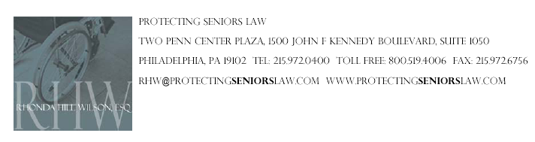

FOR IMMEDIATE RELEASE
Contact: Leah Rice
leah@furiarubel.com / 215-340-0480

Rhonda Hill Wilson Addresses Nursing Home Litigation at AAJ

PHILADELPHIA (June 16, 2008) – Philadelphia attorney, Rhonda Hill Wilson, recently served as a faculty member and speaker for the American Association for Justice’s (AAJ) Trial Advocacy College educational program “Litigation Nursing Home Cases.” The program was held at the St. Regis Resort in Fort Lauderdale, Fla., from June 6 – 10.

Hill Wilson is an active member of the AAJ organization. She is a member of the organization’s Executive and Membership Oversight Committees and the National Finance, Public Affairs, and Organization Review Committees.

Hill Wilson is an award-winning attorney who has been practicing law for nearly three decades in Pennsylvania and New Jersey. She concentrates her practice in nursing home negligence, while also handling medical malpractice, catastrophic personal injury, wrongful death, motor vehicle accident and premises liability matters. She brings a high level of integrity and compassion to her clients.

Hill Wilson serves on The Salvation Army of Greater Philadelphia’s Advisory Board helping to ensure that The Salvation Army continues to deliver outstanding services to those in need. She resides in Bryn Mawr, Pa.

About the Law Offices of Rhonda Hill Wilson
The Law Offices of Rhonda Hill Wilson, P.C., headquartered in Philadelphia, handles civil litigation of personal injury claims such as nursing-home abuse and negligence, brain injuries, medical malpractice, wrongful death, work injuries and motor-vehicle and pedestrian accidents. One of the firm’s most recent successes includes a multi-million-dollar settlement for a woman who was left in a vegetative state following a Caesarean section. Hill Wilson has been named the Pennsylvania Ambassador for the United Negro College Fund (UNCF) “A Mind Is” Annual Giving Society and has been named one of the Top Black Lawyers in the Tri- State Area by The Network Journal. She has also received the Presidential Award from the National Bar Association, is a member of the Million Dollar Advocates Forum and has been listed in Who’s Who in American Law. To learn more about the firm, visit www.rhwilson.com.

